**The Living and the Non-living**

**Warm Up!**

Make a list of the things that you see in a park. Classify the listed things in the given table on the basis of whether they can move or not.

|  |  |
| --- | --- |
| **Things that can move** | **Things that cannot move** |
|  |  |

Show children playing in a park with trees around, people sitting on a bench, children playing on a swing and see-saw, dog roaming around.

**Living and Non-LivingH1**

You may see different things around you every day. Some of them are living while some are non-living. But what does it mean to be living? All the plants and animals are living things while the objects such as car, table, chair, and pen are non-living things.

**Think it Out!**

You are aware that trees are living and things such as chair and furniture are made from wood of a tree that was once alive. Will you call a chair or other similar furniture items living or non-living?

**Common Features of Living and Non-livingH1**

Following are some common features of living and non-living things.

* **Space and mass:** All living and non-living things occupy space and have mass because everything is made up of matter.
* **Structural unit:** Both living and non-living things are composed of structural units.

Non-living things such as chalk can be broken into smaller pieces until we get the smallest piece. You may know that molecule is the smallest unit of matter. Smallest unit of a chalk is a molecule. Thus, all non-living things have molecules as their structural unit.

The structural unit of all living things is **cell** which is again made up of a number of molecules. Cells differ in size and shape. There are various kinds of cells in living things. Cells can be seen under a microscope.

Show image of "cells in onion peel.

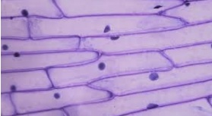(for reference)

**Characteristics of Living ThingsH1**

All living things have some features that are not present in non-living things. Following are some characteristics of living things.

* Cellular structure
* Movement on its own
* Growth
* Definite lifespan
* Excretion
* Reproduction
* Nutrition
* Respiration
* Response to stimuli

**Cellular StructureH2**

Cells are the structural unit of life. All living things are made up of cells.

Living things have a definite structural organization. A group of similar cells form a **tissue**. A group of tissues performing a similar function form an **organ**. A group of organs interacting together form an **organ system.**

Show image of structural organization in living things.

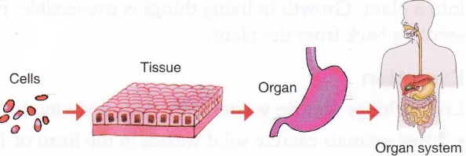**(for reference)**

Plants and animals are the multicellular organism whose body is made up of many cells. For example, humans, animals, and plants are multicellular organisms.

Some organisms are made up of a single cell. Such organisms are called **unicellular**. Paramecium and Amoeba are the unicellular organisms and a single cell carries out their life processes.

Show image of amoeba and paramecium.

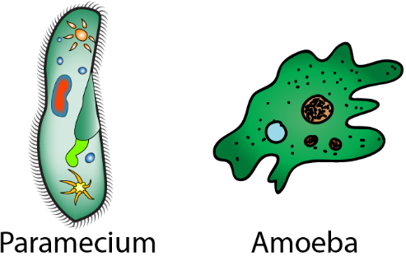(for reference)

**MovementH2**

* You may have seen animals moving. They move in search of food or shelter and to protect themselves from danger.
* Movement from one place to another is not exhibited by plants. However, some movement can be observed in certain parts of plants such as leaves and roots. For example, a sunflower moves in the direction of sun.

Non-living things such as vehicles, aeroplane and train also show movement but they do not have other characteristics of living things.

**Discussion Corner**

You may have recognized some activities such as running and walking in living things. But a robot can also run or walk. Will you call a robot a living thing?

**GrowthH2**

You may have observed that living things do not remain of same size. They increase in size as they grow older. A child grows into adult, a seedling grows into a plant and a puppy grows into a dog. In terms of size, animals stop growing after a certain period but plants continue to grow throughout their life.

Show image of growth in a child and plant.

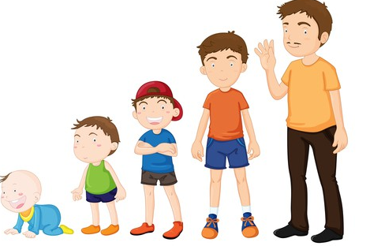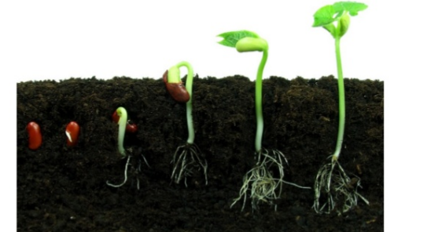(for reference)

Non-living things also show growth but the growth in non-living things occurs by the addition of materials from outside. For example, rock may become larger in size with time due to the addition of soil or sand to it.

**Break Zone**

**Match the following.**

|  |  |
| --- | --- |
| **Column A** | **Column B** |
| Plants | Grow but do not move |
| Animals | Move but do not show growth |
| Vehicles | Show growth as well as movement |
| Rocks | Grow but do not move |

**Definite LifespanH2**

Every living organism has a definite lifespan including its birth, growth and death. The longest period over which the life of an organism extends is called lifespan. Different living things have different lifespan(s). Average lifespan of some organisms are given below.

Show image of average lifespan of some organisms. (Note: Write butterfly instead of mayfly.)

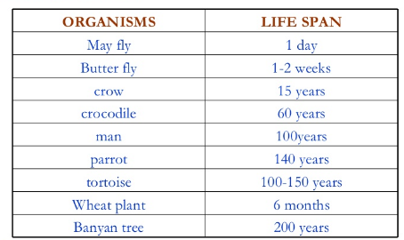(for reference)

**ExcretionH2**

Excretion is the process of removing wastes from the body. Waste products are released during life processes such as digestion and respiration, occurring inside the body of living things. These wastes are removed from the body in the form of sweat, urine and exhaled air. Plants excrete carbon dioxide and water vapour through stomata present on leaves and stem.

**Reproduction H2**

Reproduction is a process by which an organism produces an offspring. Different living organisms reproduce in different ways.

* You may know that animals such as cat or dog give birth to new animals like themselves.
* Some animals such as birds, frog, mosquitoes, snakes and spiders, hatch from eggs.
* Plants are produced from their seeds.

**Think it Out!**

Imagine what would happen if living things could not reproduce.

**Break Zone**

**Give one word for the following.**

1. The longest period over which the life of an organism extends.

2. The process of removal of waste products from the body.

3. The process of producing an offspring by an organism.

4. Plants excrete water vapour through this structure.

**NutritionH2**

Food is important for living beings as it provides energy for the life processes. Different living things have different modes of nutrition.

* Plants cannot move in search of food. They are capable of making their own food by the process of photosynthesis. They are known as **autotrophs**.
* Animals can move to obtain their food. Some animals eat only plants while some hunt other animals to get their food. Since they depend on others for their food needs, they are known as **heterotrophs**.

Some plants like insectivorous plants such as Venus Fly trap and pitcher plant are also heterotrophs. They capture and feed on insects.

**RespirationH2**

The air we breathe in is passed into the lungs; where oxygen is absorbed while carbon dioxide is removed. When we breathe out, carbon dioxide is expelled from the body. The oxygen that is absorbed combines with the digested food to produce energy. This process is called respiration.

Oxygen is the air we breathe, is used for respiration by living organisms to produce energy.

* All land animals such as humans, cows, birds and dogs breathe oxygen from air through lungs.
* Cockroaches breathe through small pores in their body.
* Earthworms breathe through their skin.
* Fishes obtain oxygen that is dissolved in water through their gills.
* Plants absorb oxygen present in air through small pores called **stomata,** present on the underside of the leaves. Plants release oxygen during day and use it during night. However, the amount of oxygen released during day is more than the oxygen used at night.

Show image of stomata, lungs and gills.

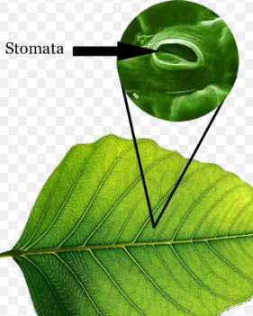 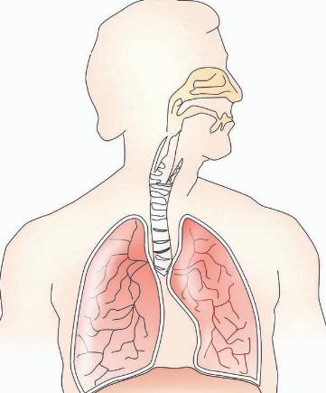 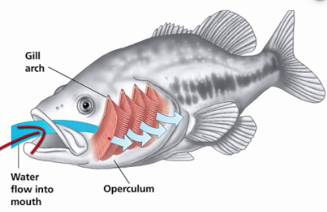 (for reference)

**Response to Stimuli H2**

What happens when you accidentally touch a hot pan? You quickly withdraw your hand, right? This is called response. The hot pan or the cause of response is called stimulus.

Do you know what happens when you touch the leaves of *Mimosa* or touch-me-not plant? Their leaves droop when someone touches it. Touch is the stimulus towards which the *Mimosa* plant is sensitive. It responds towards a stimulus by folding its leaves.

Show image of Mimosa plant (a.) before touching, (b.) after touching.

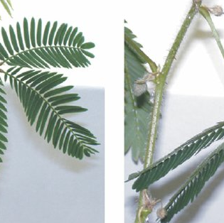(for reference)

Do plants also respond to stimuli? Have you ever seen the response of plants towards light and gravity? Let us understand this through a simple experiment.

**Activity**

To see the response of a plant towards light.

**Material required**

Potted plant

**Method:**

• Place a small potted plant near a window through which light is coming.

• Keep the plant there for few days and observe.

**Observation:**

After a few days, you will notice that the plant's tip is bent towards the direction of light coming through the window.

**Conclusion:**

Plants exhibit phototropism.

Show image of sunflower plant. Caption: "response of a plant towards light".

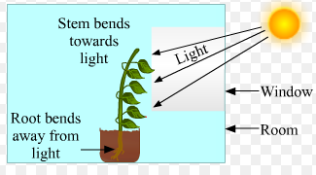(for reference)

Plants respond to light show stimulus towards light and bend in the direction of light. This response is called **phototropism**. It is the ability of the plants to grow in the direction of the source of light. For example, sunflower facing the sun shows phototropism.

Some animals such as earthworm and cockroach move away from light.

The roots of plants have a tendency to grow towards gravity while stems grow away from it. This response of root and stem growing towards and away from the gravity of earth is known as **geotropism**.

Show image of "response of a plant towards gravity".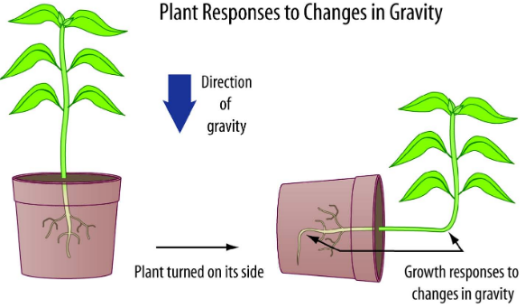(for reference)

**Break Zone**

**Write T for true and F for false statement.**

1. Deer and cow are plant-eating animals and thus are called heterotrophs.

2. Digested food combines with oxygen in our body to produce energy.

3. Earthworms breathe through small pores in their body.

4. A sunflower bending towards the sun is showing geotropism.

5. The roots of plants have a tendency to grow against the gravitational pull of earth.

**Key Terms**

**Cell**: Structural unit of living things

**Autotrophs:** Organisms that prepare their own food

**Heterotrophs**: Organisms that depend on others for their food requirement

**Phototropism:** Response of plants to light

**Geotropism:** Response of plants to gravity

**Assess Zone**

**A. Multiple Choice Questions**

**Tick the correct option**

1. Which of the following is a living thing?

a. Plastic

b. Paper

c. Plant

d. Log of wood

2. The common feature/s in a rose plant and a toy is/are

a. Both are made up of structural units

b. Both have mass

c. Both occupy space

d. All of these

3. Which of the following is/are the characteristics of living things?

a. Excretion

b. Respiration

c. Nutrition

d. All of these

4. A student observed that the growth of the root of a plant is towards the earth. This response is called

a. Phototropism

b. Geotropism

c. Tropism

d. None of the above

5. Plant stem bending towards the source of light is called?

a. Phototropism

b. Geotropism

c. Tropism

d. None of the above

6. A teacher asked students to give example of phototropism. Which student gave the correct response?

a. Student 1: Sunflower bending towards the sun.

b. Student 2: Root of plant growing against earth.

c. Student 3: Stem of plant growing against the earth.

d. Both student 1 and 3.

**B. Mark the given sentences T if true or F if false**

1. All living things are made up of cells.

2. Growth is the characteristic of both humans as well as stones.

3. Amoeba is made up of more than one cell.

4. Plants respire through stomata.

5. Herbivores such as cow, goat and deer are called autotrophs.

**C. Short answer type questions**

##### Write the common features of living and non-living things.

##### Give examples of living things that cannot move and non-living things that can move.

1. What are the characteristics of living things?
2. How do land animals such as earthworm, a dog and cockroach respire?
3. How do the stomata help plants in respiration and excretion?
4. Give examples of plant eating and flesh eating animals.
5. What is the response of roots of a plant towards the earth?

**D. Long answer type questions**

1. Differentiate between a robot and a human on the basis of growth and movement.
2. How do different living things obtain nutrition? Explain.
3. Explain four different ways by which different organisms carry out respiration, with examples.
4. When a potted plant is kept near the window, its stem bends in a certain direction. Explain this observation.
5. A plastic bag is tied around the stem of a plant. After sometime you observed water droplets in the bag. What is the reason for this? Explain.

**Diagram Based Question**

Pluck the leaves of a plant such as hibiscus. Now fold the leave and scratch the surface carefully with blade to obtain a thin, transparent or membranous peel. Now stain the peel with safranin solution and transfer the stained peel to a clean and dry slide. Observe it under a microscope. You will observe the given structure. Identify the structure and explain its importance in plants?

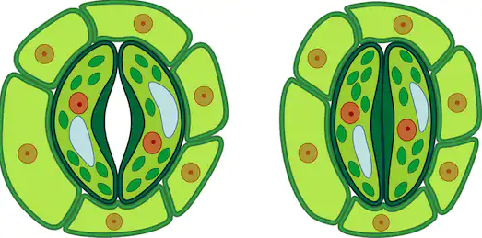

**Values in Life**

You may have seen people taking care of plants in their garden or people taking care of their pets. People take their pets for a walk, feed them regularly and take care of their cleanliness. These behaviours show that people are sensitive towards living beings. You should also be sensitive towards living things such as plants and animals because living things can sense what is happening around them. Thus, you should not harm any animal or plant.

**Lesson Map**

**Know More**

***Bishnoi Andolan***

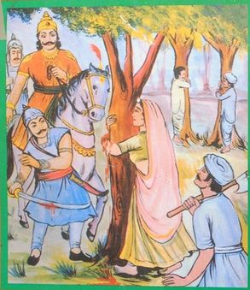

Amrita Devi, along with her three daughters, sacrificed her life to save trees of her village in Rajasthan. The Maharaja of Jodhpur once ordered to cut the *khejri* trees of the village for the construction of his new palace. Amrita Devi protested against King's men who were trying to cut trees as they were significant to *Bishnoi*s. She said while hugging the tree "if a tree is saved even at the cost of one's head, it's worth it". The axes brought to cut the trees severed her head. Hearing this, many *Bishnoi*s from the villages around gathered and protested against the cutting of trees by embracing them.

**Project Work**

Study and compare the life processes of different animals living on land and water. Fill the table given below.

|  |  |  |  |
| --- | --- | --- | --- |
| **Animals** | **Respiration** | **Excretion** | **Digestion** |
| Fish |  |  |  |
| Plants |  |  |  |
| Humans |  |  |  |
| Cow |  |  |  |

**Green Club**

Collect information on "*Chipko andolan*". Find out the place where it originated and the person who initiated it. Spread awareness around your neighborhood through posters and slogans to protect trees.